You can dowload Qt5.12.3 from <http://download.qt.io/archive/qt/5.12/5.12.3/>; Please select [qt-opensource-windows-x86-5.12.3.exe](http://download.qt.io/archive/qt/5.12/5.12.3/qt-opensource-windows-x86-5.12.3.exe) and download it.

Open [qt-opensource-windows-x86-5.12.3.exe](http://download.qt.io/archive/qt/5.12/5.12.3/qt-opensource-windows-x86-5.12.3.exe)

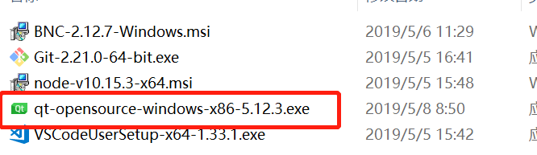

Wait a minute when the [next] is enable, then click next.

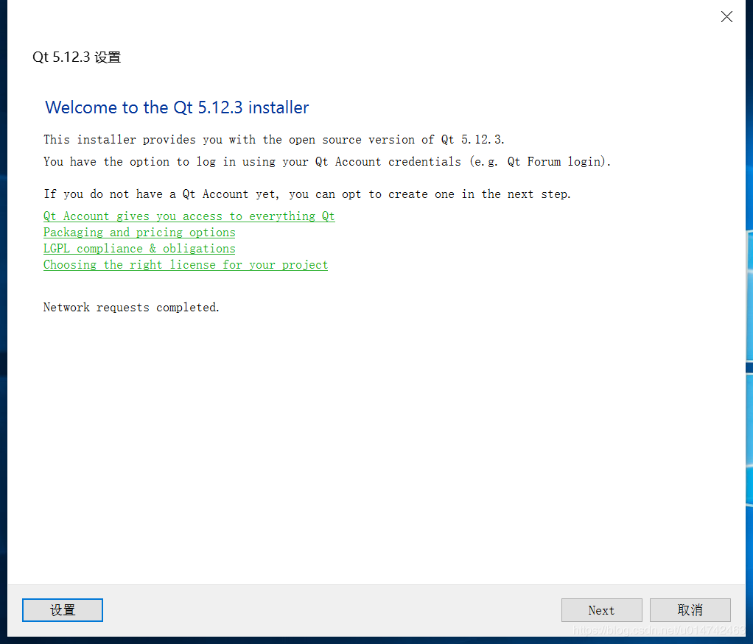

You can login if you have a qt account, if you don’t have account you can [skin] it.

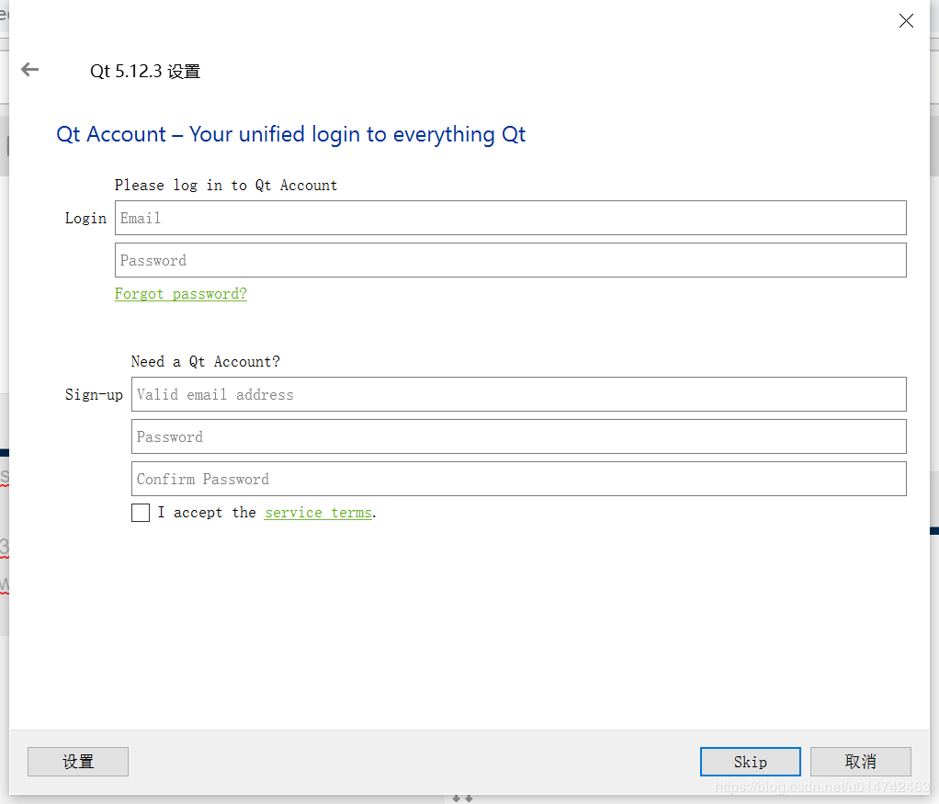

Click [next].



Select a path to install Qt.

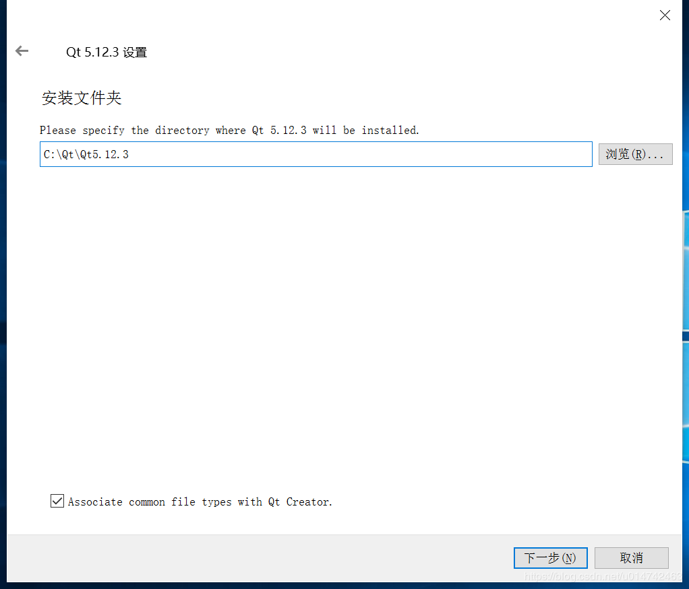

Select [MSVC 2017 64-bit] and click [next].

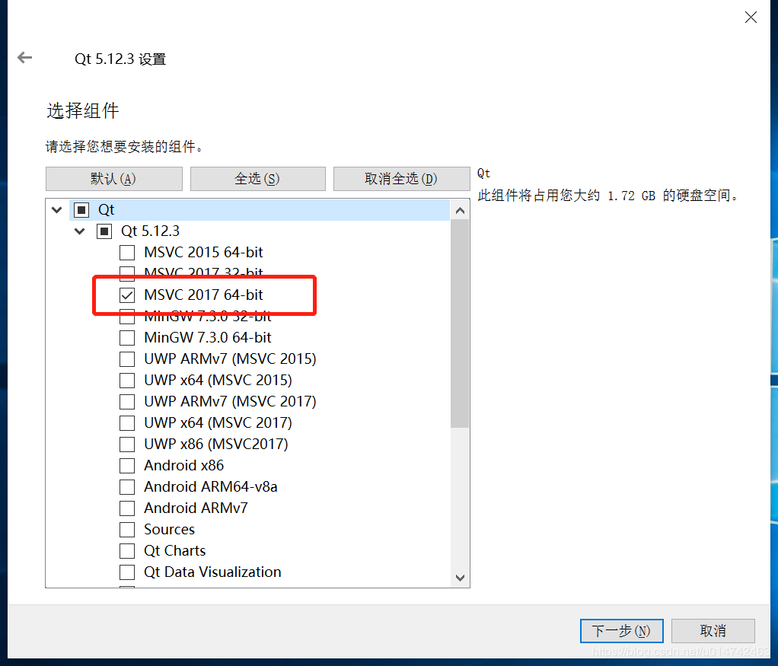

Select [I have read and agree…] and click [next].

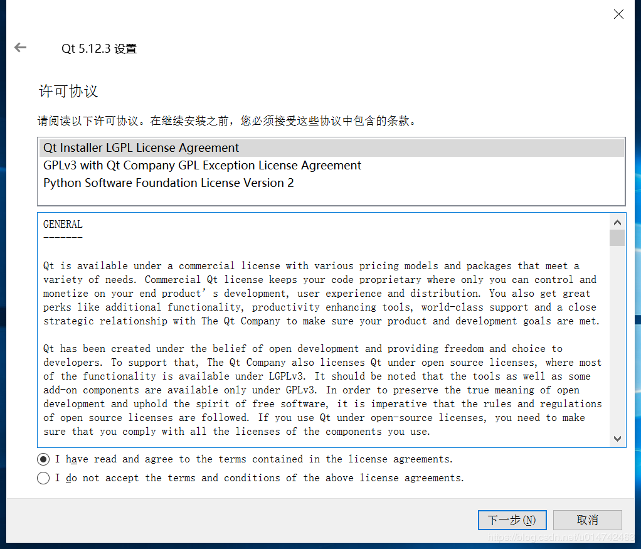

[next]

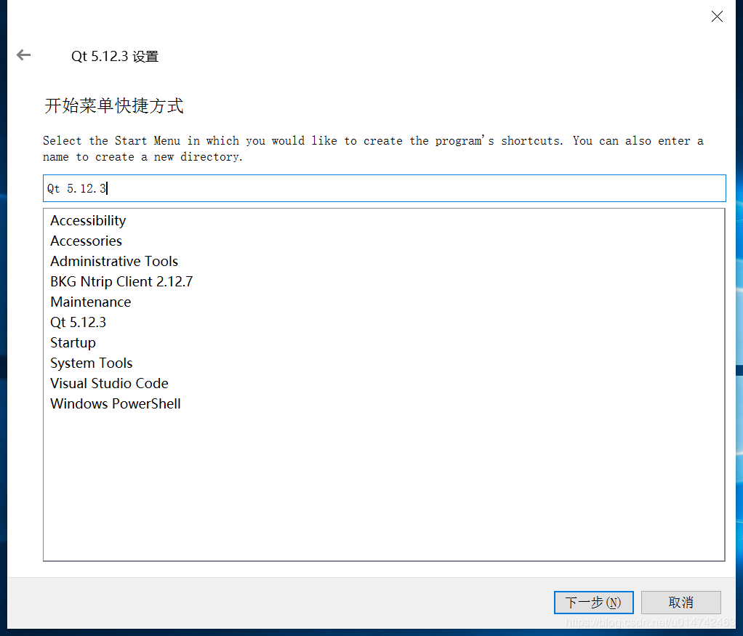

[install]